Sri Lanka Institute of Information

Technology



Lab Submission

Lab sheet No 8

**IT24100975**

**Haggalage H.H.D.S**

**IT2120 - Probability and Statistics**

B.Sc. (Hons) in Information Technology

**Exercise**

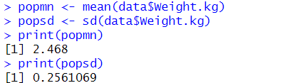1.

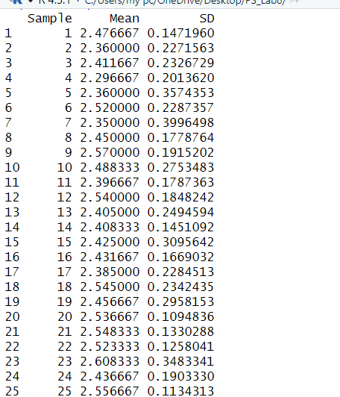2.

3.

